Instructions to Make Above Ground Garden Boxes
(These instructions will make (2-2’X4’) garden boxes.)
**Box dimensions can be modified to fit the needs of your space.
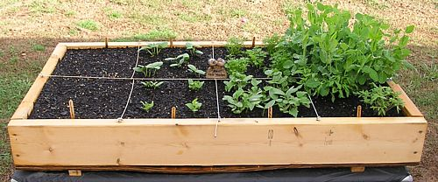

Materials Needed to Make Above Ground Garden Boxes
3- (2’×10”x8’ pieces of untreated lumber) Example: Untreated Douglas Fir or Cedar
Don’t get treated lumber because treatments can seep into the soil and contaminate your planting area.
16- (#8 x 3″ wood screws)
Use these longer screws to connect the corners of the above ground garden box.
16- ( #6 x 1″ wood screws)
Use these anchor the twine to create a grid system for the 1×1 planting plots.
1 pack of twine
Use this to create a grid system on top of the container, in 1×1 square foot patterns.
16 cu ft. of garden soil (for flowers and vegetables)
You will need 8 cu ft. of garden soil per (2X4’) garden box.

Instructions to Make Above Ground Garden Boxes
(These instructions will make (2-2X4’) garden boxes.)
- Cut your 3- 2’X10”X8’ pieces of untreated lumber down to size. (Most hardware stores provide a service to cut your lumber. Some stores offer the service at no-cost, other stores charge a fee.)
  - Cut two of the boards in half, so you are left with 4-4 foot long boards. See picture below.
4’
4’
4’
4’

  - Cut the remaining board into 4-2 foot pieces. See picture below.
2’
2’
2’
2’

- Next, position the boards in a rectangular pattern, alternating corners to make the “inside box” dimensions four feet by two feet. Fasten the sides using the #8×3″ wood screws. If you have trouble with the wood splitting, you may want to first drill pilot holes.
2’
4’
- Create a grid system on top of the square foot gardening container using twine and #6×1″ screws, spaced a foot apart across the width and length of the container. Drill the screws about half way into the top of the 2×6s, leaving enough room to tie a knot of twine around the screw.
2’
4’

