Instructions to Make a Bean Teepee
You will need: 7 - 9 long bamboo poles, some twine, string or even masking tape, and runner or pole beans.
1. | Start off by finding a suitable spot in your garden and dig the earth over in a circular shape. A circle with a diameter of 3-4 foot is usually perfectly adequate.  Beans like well-drained soil, so add some compost and fertilizer if needed - like in this example!
2. | Firmly push the ends of the bamboo poles into the ground by about 3 inches on the outside of the circle.  Leave a gap between two of the poles to act as the entrance to the bean teepee.
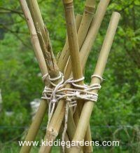  3. | Tie the bamboo poles together firmly near the top using twine, string, a bit of old rope or even masking tape.  There is absolutely no fine art in tying the poles together - the main and only aim is to ensure they are all VERY firmly held in place, as no matter how careful kids are, they are likely to knock the poles when going in and out of the teepee.
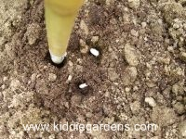  4. | Plant the runner or pole beans about 2 inches deep. Plant them on the inside of the teepee rather than the outside, as this makes it easier to hoe and keep weeds down - anything growing on the outside of the bamboo poles are weeds! It is usual to plant two beans per pole. That should ensure at least one healthy plant per pole.
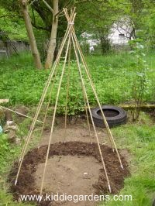  5. | Water generously.  Beans usually take between 7 to 14 days to germinate. Once the seedlings appear, protect them from slug attacks.  When the beans are a few inches high, loosely tie them to the poles. From then on, they should find their own way up.  When the plants reach the top of the teepee after about 7-8 weeks, nip the growing ends off. Keep them well watered during a dry patch, especially once the pods have started forming.

Instructions found: www.kiddiegardens.com.

